STEP 1:  ENTER STUDENT NUMBER:  ENTER PIN:  STEP 2:  Now it will force you to change the PIN, the pin must be 5 numerical digits, not starting with a zero. |  |  | Step 3:  “Click on “REGISTRATION” (on the left hand side”  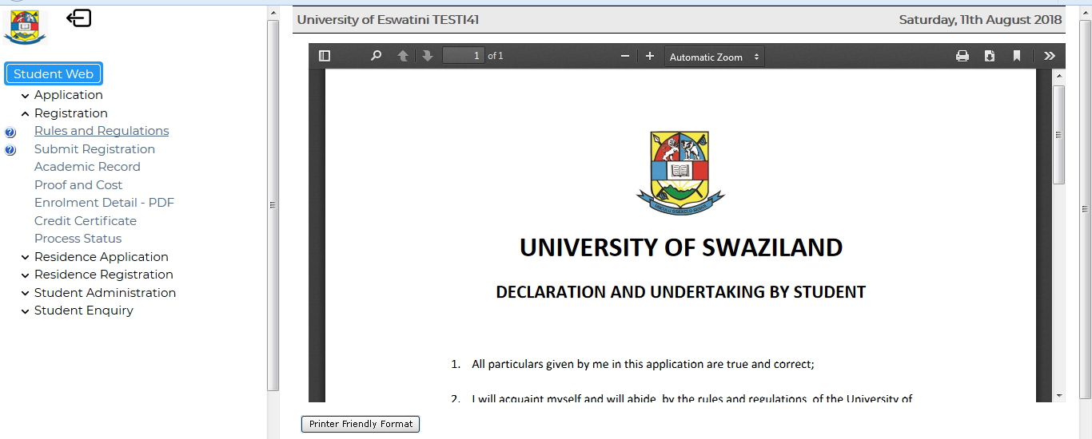  Step 4:  “Read through the Rules and Regulations and click on the “I ACCEPT” botton
 | Step 5:  The following will display  Step 6:  Click on SUBMIT REGISTRATION and enter your “Employment Status” list Click “On Save and Continue” below.  Step 7:  The subjects will display, CLICK on “SAVE and CONTINUE” |  |  | Step 8: Check if all the Subjects are displaying for registration, tick the courses you have to register for this semester, then “CLICK on SAVE AND CONTINUE”
 |  | Step 9:  A list of the courses you have selected will display, CLICK on “ACCEPT REGISTRATION” |  |  | Step 10:  “PROOF OF REGISTRATION” will display. Click on the Print button to print.  Print “THREE COPIES”  Welcome to the University of Eswatini you are now a registered student

